# PeopleSafe - Claims Coordination of Benefits (COB) Mail Order Only

COB Claim Submission

 Entering Member Supplied COB Information

Updating Member Supplied COB Information

Member Issues with Claims Paid via COB

Frequently Asked Questions

Related Documents

**Description:** Provides instructions on how to submit a claim and coordinate members benefits if the Plan/CIF Allows.

|  |
| --- |
| COB Claim Submission |

When the member has questions regarding claim submission and/or coordination of benefits; perform the following steps:

|  |  |  |  |
| --- | --- | --- | --- |
| **Step** | **Action** | | |
| **1** | Confirm eligibility by checking the member’s CIF. | | |
| **2** | View the Delivery systems: (A check mark indicates how the Rx’s will be accepted).  The members Paper Claim address maybe different depending on the delivery system utilized.   * Home Delivery * Paper Claim * Point of Sale | | |
| **If the Plan Design…** | **Then…** | |
| Has Paper Claims | Review the Paper Claims section of the CIF for COB information. | |
| **If COB is…** | **Then…** |
| NOT allowed | Inform the member. |
| Allowed | * Ask the member to complete a Paper Claim form. * Enclose the Explanation of Benefits statement from their primary carrier. * Write **COB** below the Patient Information section of the form. * Mail to our Mail Order pharmacy address on the form for reimbursement consideration. |
| Does NOT have Paper Claims | * Inform the member as to the type of prescription coverage they have in their Plan Design. * Recommend member to contact their major medical coverage for information about “Filing a Claim” for reimbursement on medications purchased at a retail pharmacy.   Do not guarantee this is a medical benefit, but only a suggestion to inquire. | |

Top of the Document

|  |
| --- |
| Entering Member Supplied COB Information |

  This is for Coordination of Benefits for Mail Order only. CCR please check CIF before doing next steps. CIF will state if Mail order COB is allowed (In CIF under Retail Logic: Online COB Processing). If so, proceed to the next steps.

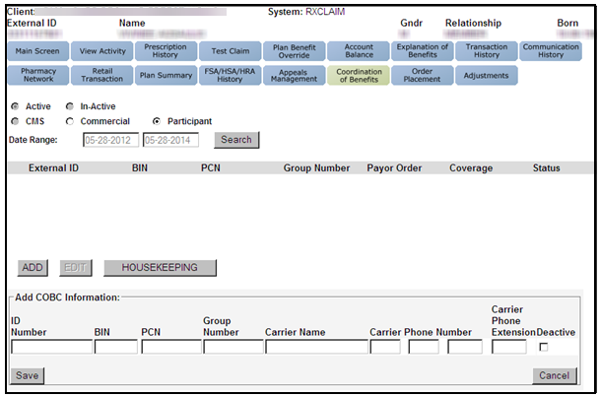

**Notes:**

* **Secondary insurance** information can only be entered on the RxClaim processing platform for clients that allow COB.
* Review the **Paper Claims** section of the CIF for COB information.
  + **If Secondary insurance is also managed by our Mail Order pharmacy, check both clients CIF to ensure that both clients allow COB.**
* It is recommended that the member verify with their **Secondary insurance provider (PBM) that COB is allowed and that our Mail Order pharmacy is considered in-network.**

Perform the following steps:

|  |  |
| --- | --- |
| **Step** | **Action** |
| **1** | Select the **Coordination of Benefits** tab, then click the **Participant** radio button, click **Search** then click **Add**. |
| **2** | a. Input the information about the additional PBM provided by the caller into the appropriate fields.  **Note:** The following information should be displayed on the members ID Card:   * ID number for the account * Bank Identification Number (BIN) * Processor Control Number (PCN) * Group Number * Carrier Name * Carrier Phone Number * Carrier Extension (optional)   b. Suggest that the member confirm with their secondary insurance that CVS Caremark Mail Order Pharmacy is in their network. |
| **3** | Advise the member that if their coverage changes, they should contact Customer Care to update their records. |
| **4** | Verify that the information is correct and click **Save.**  **Note:** COB information affects Mail Order claims only. |

Top of the Document

|  |
| --- |
| Updating Member Supplied COB Information |

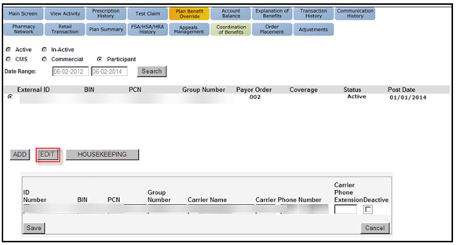

Perform the following steps: ( This is for Coordination of Benefits for Mail Order only).

|  |  |
| --- | --- |
| **Step** | **Action** |
| **1** | Select the **Coordination of Benefits** tab and click the **Participant** radio button then select **Search** and **Edit**. |
| **2** | Update the COB information as directed by the member.  **Note:** If the member is calling to state that the line of coverage is no longer active, click the **Deactive** checkbox.  COB information provided by the member cannot be deleted from the profile. |
| **3** | Verify the information is correct and click **Save**. |

Top of the Document

|  |
| --- |
| Member Issues with Claims Paid via COB |

If the member claims that their claim was not paid correctly using Coordination of Benefits, research the issue by performing the following steps:

|  |  |  |  |  |  |
| --- | --- | --- | --- | --- | --- |
| **Step** | **Action** | | | | |
| **1** | Click on the Order Number from the Main Screen.    **Result:** The Order Status screen displays. | | | | |
| **2** | Click on the Order Number.    **Result:** The Verify Order screen displays. | | | | |
| **3** | View the Order Line Items section of the screen to determine what information is listed under the Batch # field. | | | | |
| **If…** | **Then…** | | | |
| Blank | Determine if the account is an EGWP or STCOB account. | | | |
| **If…** | | **Then…** | |
| No | | Claim **was not** processed with Coordination of Benefits.  Assist the member by explaining the reason for their copay by performing a Test Claim. | |
| Yes | | Review the Supplemental Financials on the Claim Financials screen to:   * + - View Dispense as Written (DAW) surcharges and deductibles that are charged on the secondary account, if any.     - View the amount the secondary plan paid on the claim. * View rejection reasons that occurred on the secondary account. | |
| “S” (for Secondary) is present | Claim **was** processed with Coordination of Benefits. Proceed to the next step. | | | |
| **4** | Click the **Coordination of Benefits** tab. | | | | |
| **5** | Verify the member’s secondary line(s) of coverage are correct as listed. | | | | |
| **If…** | | **Then…** | | |
| Correct | | Proceed to the next step. | | |
| Incorrect | | Determine the provider of the COB information. | | |
| **If…** | | **Then…** |
| CMS or Commercial | | Proceed to the next step. |
| Member | | * Update as appropriate, refer to the steps in Updating Member Supplied COB Information. * Proceed to the next step. |
| **6** | Create a Reverse and Reprocess task. Follow the steps listed in the [Copay - Mail Order Reverse and Reprocess Claim (021894)](https://thesource.cvshealth.com/nuxeo/thesource/#!/view?docid=5d4876c1-e43f-41d8-ba45-0e4a72aee882) of the Copay Mail Order Reverse and Reprocess Claim.  **Note:** Begin your note in the RM task with “COB”. | | | | |

Top of the Document

|  |
| --- |
| Frequently Asked Questions |

Refer to the table below:

|  |  |
| --- | --- |
| **Question** | **Answer** |
| How should CCRs handle a call where the member is saying that coordination of benefits did not pay the way it was supposed to? | Refer to Member Issues with Claims Paid via COB. |
| Sometimes plans determine which pays first/second based on Date of Birth. Can you please clarify how we know in what order the plans will pay? | On the COB screen there is a column titled ‘Payer Order’. When data is populated on the Commercial View, it will have order ranking populated as well.  As for Participant View, this field is not editable so it’s not applicable as our Mail Order pharmacy profile is viewed as the primary coverage. |
| Is the Coordination of Benefits (COB) data member specific? Will COB data have to be entered for each member? | If the member says that they have other coverage to add, then it will be added under the Member provided.  However, for COMM COB this is an eligibility feed from the client’s benefits office. |
| Is the COB pricing for commercial Plan Pay or Member Pay pricing? | The final pricing will be member pay.  The secondary pricing will provide how much the plan will cover and the difference will be added to the member pay. |
| If we are not the primary insurer and a claim is processed through us first will we receive a “submit to other payer” rejection? | No, we would process the claim as normal. |
| In regard to HIPAA, what authentication measures need to be taken when collecting COB information from a member/wife/dependent/authorized party? | If authentication was taken to view the account, then add secondary coverage. |
| If manufacturer coupons contain the same information as an ID card (bin, pcn, group, etc.); will they be able to be entered as COB information? | No. |
| COB at retail Pharmacies | If Member calls Caremark about a reject code 41 at retail and no longer has 2 policies, Member should call the primary Policy to have information updated. |

Top of the Document

|  |
| --- |
| Related Documents |

[Log Actvity/Capture Activity Codes (005164)](https://thesource.cvshealth.com/nuxeo/thesource/#!/view?docid=bdac0c67-5fee-47ba-a3aa-aab84900cf78)

[Customer Care Abbreviations, Definitions, and Terms (017428)](https://thesource.cvshealth.com/nuxeo/thesource/#!/view?docid=c1f1028b-e42c-4b4f-a4cf-cc0b42c91606)

**Parent Document:** [CALL 0049 Customer Care Internal and External Call Handling](https://policy.corp.cvscaremark.com/pnp/faces/DocRenderer?documentId=CALL-0049)

Top of the Document

Not to Be Reproduced or Disclosed to Others without Prior Written Approval

**ELECTRONIC DATA = OFFICIAL VERSION / PAPER COPY = INFORMATIONAL ONLY**